**1.Pg 451**

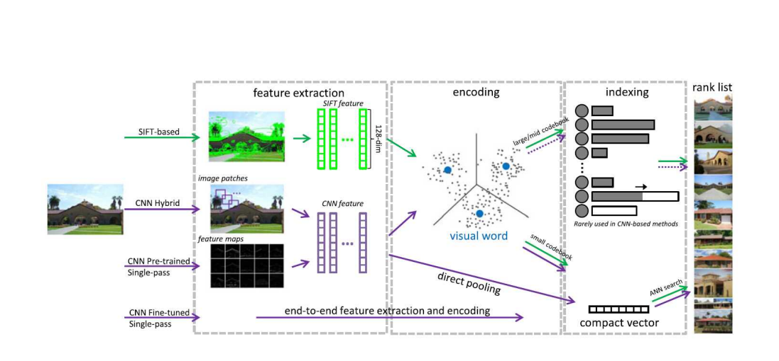

**2.1**

2.2

3.2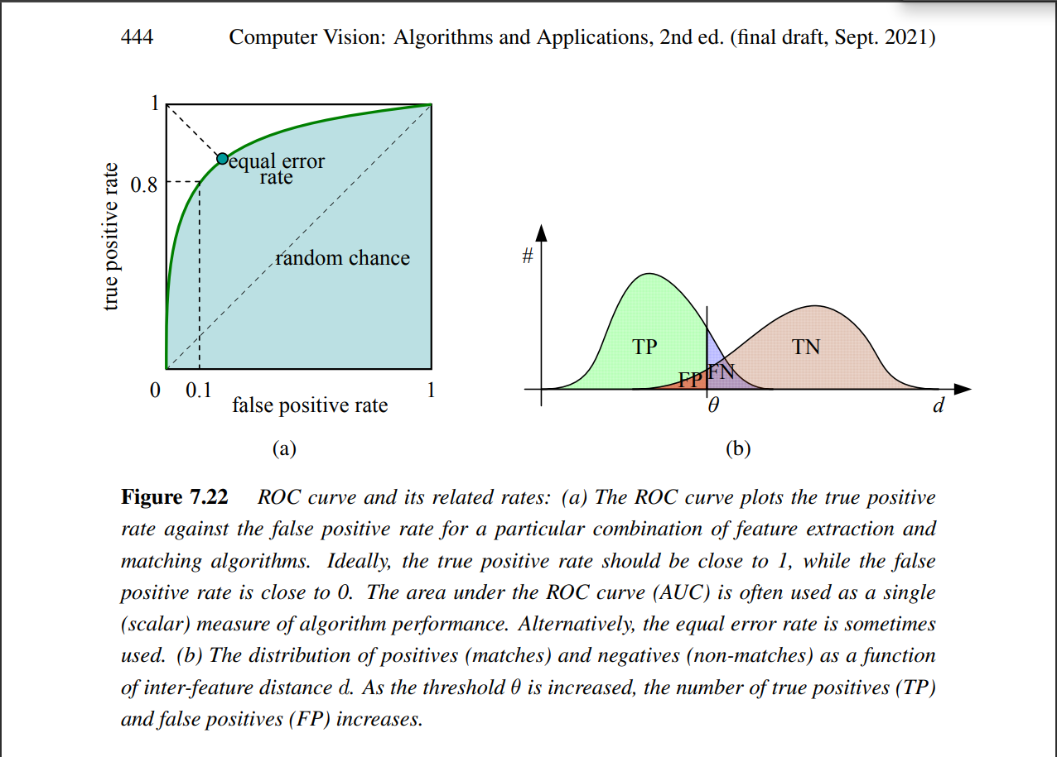

4

